ASP.NET Core 8.0 Web API

1. Objective
To understand RESTful Web Services, Web API, Microservices, HTTP requests and responses, HTTP action verbs, HTTP status codes, Web API structure and configuration files, and to create and execute a simple ASP.NET Core Web API with Read/Write action methods.

2. Software / Tools Used
- Visual Studio
- ASP.NET Core Web API
- C#
- .NET Core / .NET
- Web Browser

3. Theory

3.1 RESTful Web Service, Web API and Microservice
REST (Representational State Transfer) is an architectural style used for designing web services. RESTful services are generally stateless, use standard HTTP methods, and exchange representations of resources through HTTP messages. A Web API provides endpoints that applications can access over HTTP. It is not restricted to returning XML and can return formats such as JSON. A microservice is a small, independently deployable service designed around a specific business capability.

3.2 HTTP Request and HTTP Response
An HTTP request is sent by a client to a server to request or modify a resource. It contains information such as the HTTP method, URL, headers and, when required, a request body. An HTTP response is returned by the server and contains a status code, headers and, when applicable, a response body.

3.3 HTTP Action Verbs
Action Verb | Purpose | Typical Attribute
GET | Read / retrieve data | [HttpGet]
POST | Create / submit new data | [HttpPost]
PUT | Update existing data | [HttpPut]
DELETE | Delete data | [HttpDelete]

3.4 Common HTTP Status Codes
Status / Result | Meaning
Ok | Request completed successfully.
BadRequest | The request sent by the client is invalid.
Unauthorized | Authentication is required or the request is not authorized.
InternalServerError | An unexpected error occurred on the server.

3.5 Web API Structure
A controller handles incoming API requests. In ASP.NET Core Web API, controllers commonly inherit from ControllerBase. Action methods inside the controller handle HTTP requests. Attributes such as [HttpGet], [HttpPost], [HttpPut] and [HttpDelete] map action methods to the corresponding HTTP verbs.

3.6 Configuration Files
- Program.cs – configures services and the HTTP request pipeline in modern ASP.NET Core applications.
- appsettings.json – stores application configuration settings.
- launchSettings.json – contains development launch profiles and local application settings.
- Startup.cs – used in older ASP.NET Core versions for service registration and application configuration.
- RouteConfig.cs and WebApiConfig.cs – commonly used in older ASP.NET MVC / Web API applications for routing configuration.

4. Procedure
1. Open Visual Studio and create a new project using the ASP.NET Core Web API template.
2. Name the project ApiLab1 and create the project with the required Web API configuration.
3. Observe the Controllers folder and the default WeatherForecastController.
4. Run the application using the HTTPS launch profile.
5. Verify that the application starts successfully and note the local HTTPS URL.
6. Open the WeatherForecast GET endpoint in a web browser.
7. Verify that the GET action returns the expected weather forecast data in JSON format.
8. Create/observe a controller with Read/Write action methods corresponding to GET, POST, PUT and DELETE.

Figure 1: ApiLab1 project structure showing the Controllers folder and WeatherForecastController.
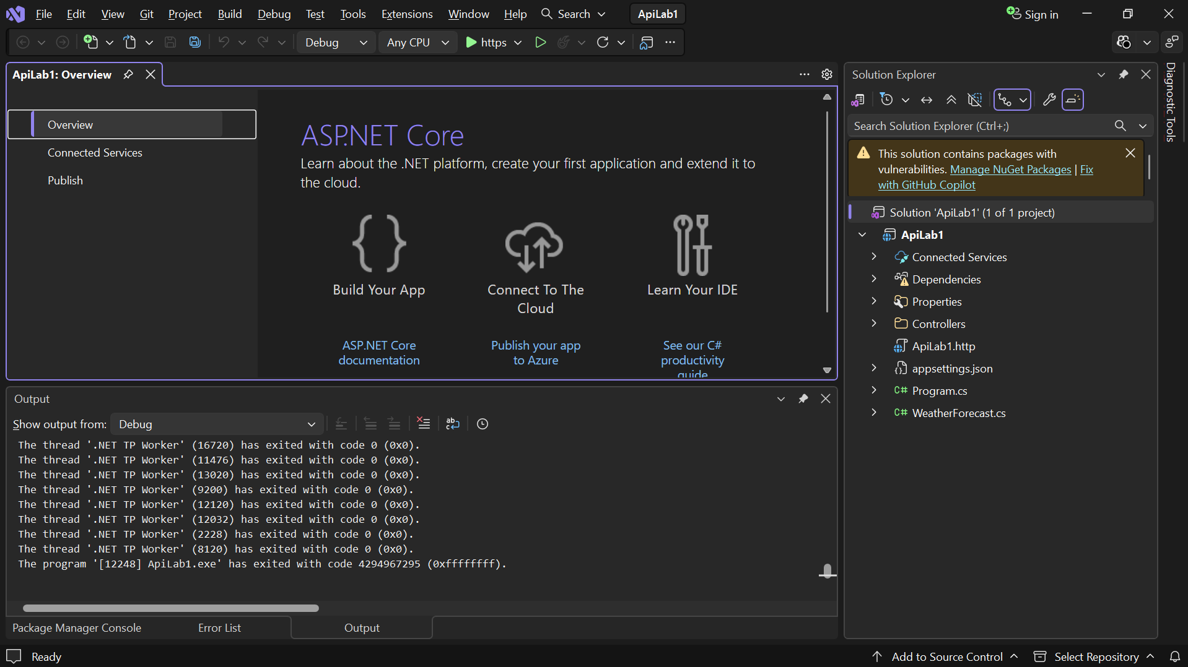

Figure 2: Application running successfully, showing the local HTTPS URL and Application started message.
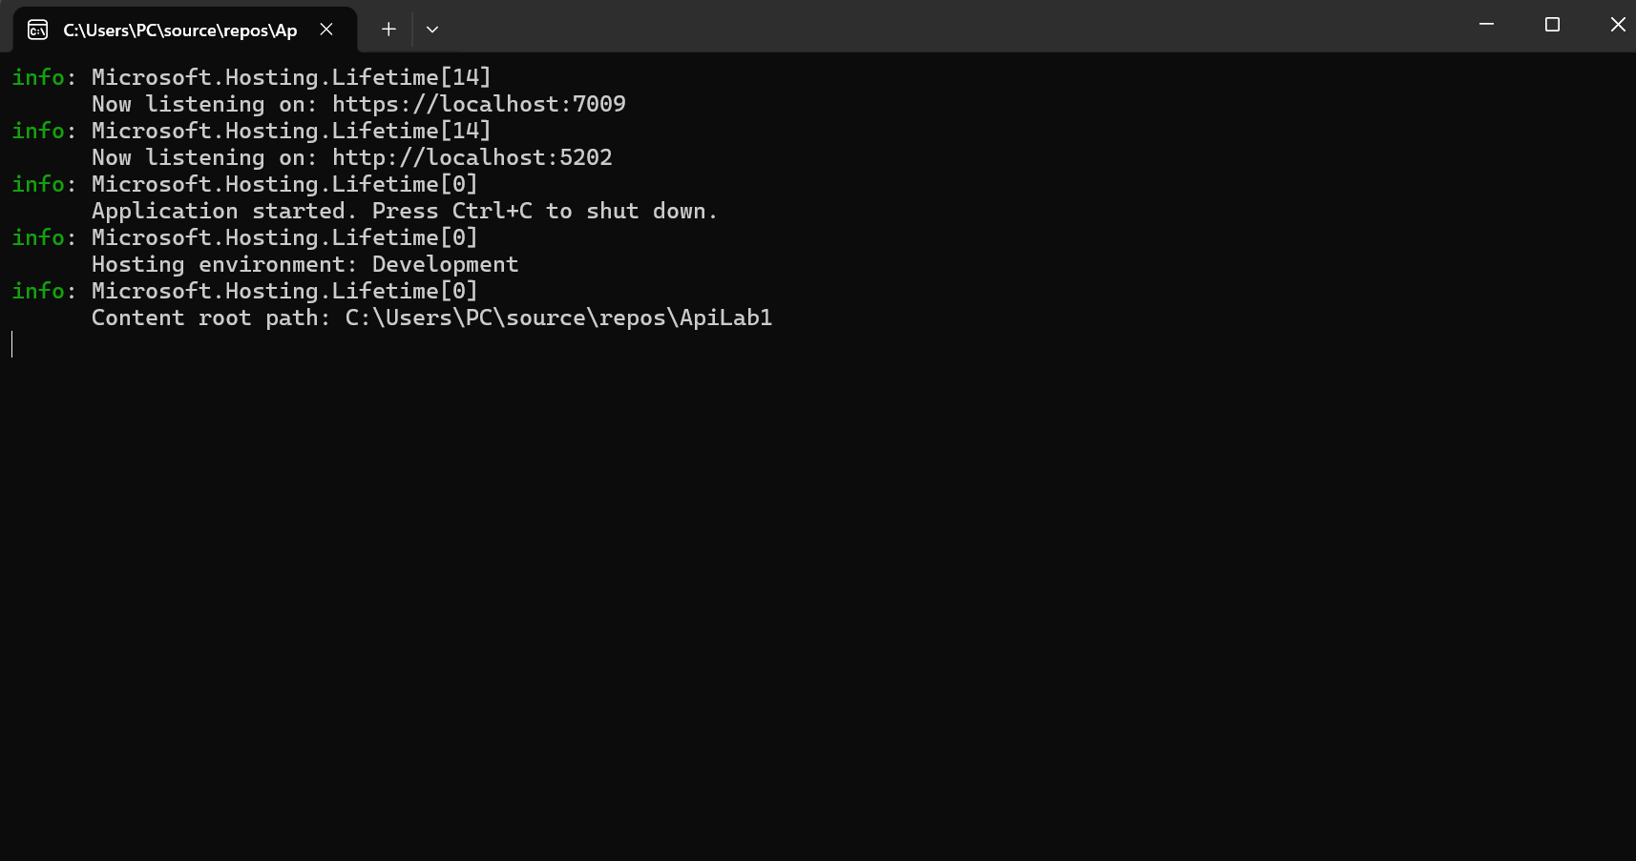

Figure 3: GET action output showing the weather forecast JSON response.
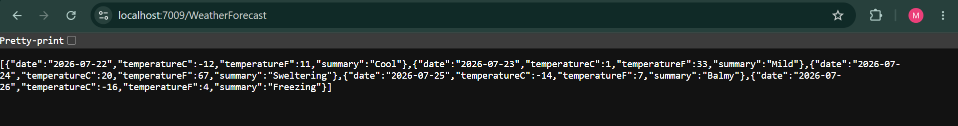

ValuesController showing the HTTP action methods GET, POST, PUT and DELETE.

ValuesController.cs
using Microsoft.AspNetCore.Mvc;

namespace ApiLab1.Controllers
{
[ApiController]
[Route("api/[controller]")]
public class ValuesController : ControllerBase
{
// GET: api/Values
[HttpGet]
public IActionResult Get()
{
return Ok(new string[] { "Value1", "Value2", "Value3" });
}

// POST: api/Values
[HttpPost]
public IActionResult Post([FromBody] string value)
{
return Ok("Value added successfully: " + value);
}

// PUT: api/Values/1
[HttpPut("{id}")]
public IActionResult Put(int id, [FromBody] string value)
{
return Ok("Value with ID " + id + " updated to: " + value);
}

// DELETE: api/Values/1
[HttpDelete("{id}")]
public IActionResult Delete(int id)
{
return Ok("Value with ID " + id + " deleted successfully.");
}
}
}

5. Result
The ASP.NET Core Web API application was successfully created using the Web API template and executed successfully. The controller structure and HTTP action methods corresponding to GET, POST, PUT and DELETE were demonstrated. The GET action method was executed and the expected weather forecast data was successfully returned in JSON format.

